**Question:**

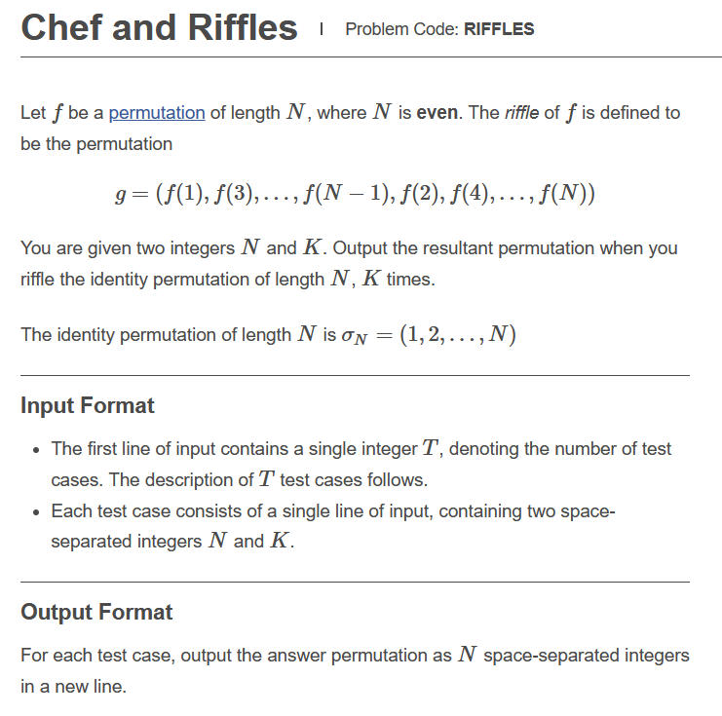

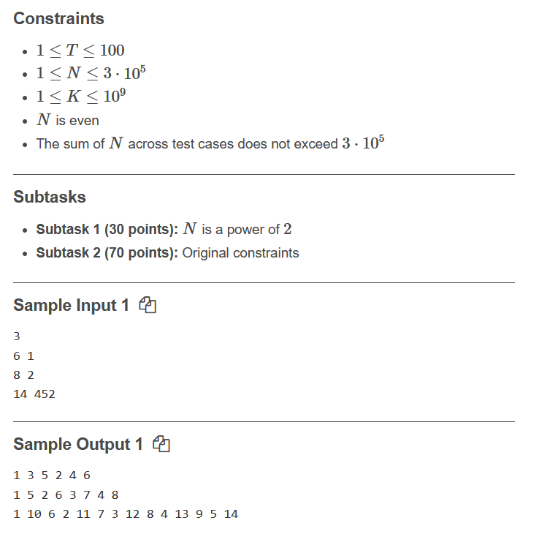

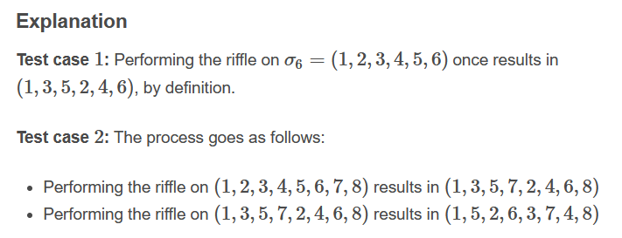

**Link: https://www.codechef.com/JAN221C/problems/RIFFLES**

**Code:**

**#include<bits/stdc++.h>**

**#define ll long long**

**using namespace std;**

**int main()**

**{**

**int input;**

**cin>>input;**

**ll n,k;**

**for(int i=0;i<input;i++)**

**{**

**cin>>n>>k;**

**ll call=log2(n);**

**ll win=k-((k/call)*call);**

**ll arr[n+2],arr2[n+2];**

**for(ll i=1;i<=n;i++)**

**{**

**arr[i]=i;**

**arr2[i]=i;**

**}**

**for(int i=0;i<win;i++)**

**{**

**int one=1;**

**int two=2;**

**for(int j=1;j<=(n/2);j++)**

**{**

**arr[j]=arr2[one];**

**one=one+2;**

**}**

**for(int j=(n/2)+1;j<=n;j++)**

**{**

**arr[j]=arr2[two];**

**two=two+2;**

**}**

**for(int j=1;j<=n;j++)**

**{**

**arr2[j]=arr[j];**

**}**

**}**

**for(int i=1;i<=n;i++)**

**{**

**cout<<arr[i]<<" ";**

**}**

**cout<<endl;**

**}**

**return 0;**

**}**

**Solution: Partially Correct(30 points)**